Desktop Multifunction Pop Up PowerPod - 3x UK Sockets 2x USB (PDU-P-3W-2USB-XW)

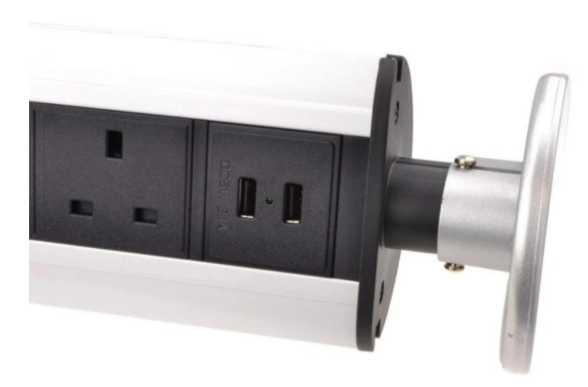

Description:
The LMS Power PDU-P-3W-2USB-XW is a versatile, must-have power pod for your computers, mobile devices and other devices that need reliable power and charging points without the associated mess.
Do away with messy extension blocks, trailing cables at home or in the office, the PowerPod simply slots into the standard accessory hole found in desks, benches and work stations.
Stylish in design, screw thread coupling for desk holes and its unique pop-up design means it does not take any desk space when not in use. Robust aluminium chassis, a generous length power flex connected to a BSI rated 13 Amp UK plug.

Key Features:
Standard UK 3-Pin power outlets for all your desktop needs
Integral dual USB charging points for your devices
Universal standard 80mm hole thread for majority of desks
Spring loaded function, hides in the desk when not in use
Backed up by LMS Power's exclusive 3-year warranty

Applications:
Create instant power feeds to your data, telecom or server cabinets
Provide effective power for cabinet cooling fans, UPS systems
Ideal as stand-alone trailing sockets outside the cabinet

Product Code:
Part Number: PDU-P-3W-2USB-XW
EAN: 8400800032584
Weight: 0.7Kg approx

Technical Specifications:
Warranty LMS Data 3-Year Warranty
Hole Size 80mm diameter for desks
Output Sockets 3 UK 3-PIN Sockets
USB Ports 2 USB Charge Ports 5V, 2.1 Amp
Power Input Fitted UK 3PIN BSI Plug 13 Amp
Flex Length 1.8 metres (approx)

Supplied With:
PDU-P-3W-2USB-XW Pop Up PowerPod
Fitted 1.8 metre BSI UK 13 Amp flex and Plug
* Specifications and product design are subject to change. E&OE.

